RC Swap Meet Saturday, Nov.4, 2017
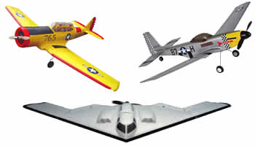
Sponsored by: High Country Flyers
Kamloops Indian Band – Moccasin Gym
200-330 Chief Alex Thomas Way
Kamloops, BC
$12.00 per table
Vendor Unloading 07:30 - 9:00
Doors open at 9:00 am
$ 3.00 - Admission
*No Selling before 09:00

